**PYTHON REST API NODEJS CLIENT**

**INSTALLING EXPRESS.JS AND CREATE A NODE PROJECT (USING EXPRESS GENERATOR):**

**REF:** <http://expressjs.com/es/starter/generator.html>

FIRST WE NEED TO INSTALL EXPRESS GENERATOR:

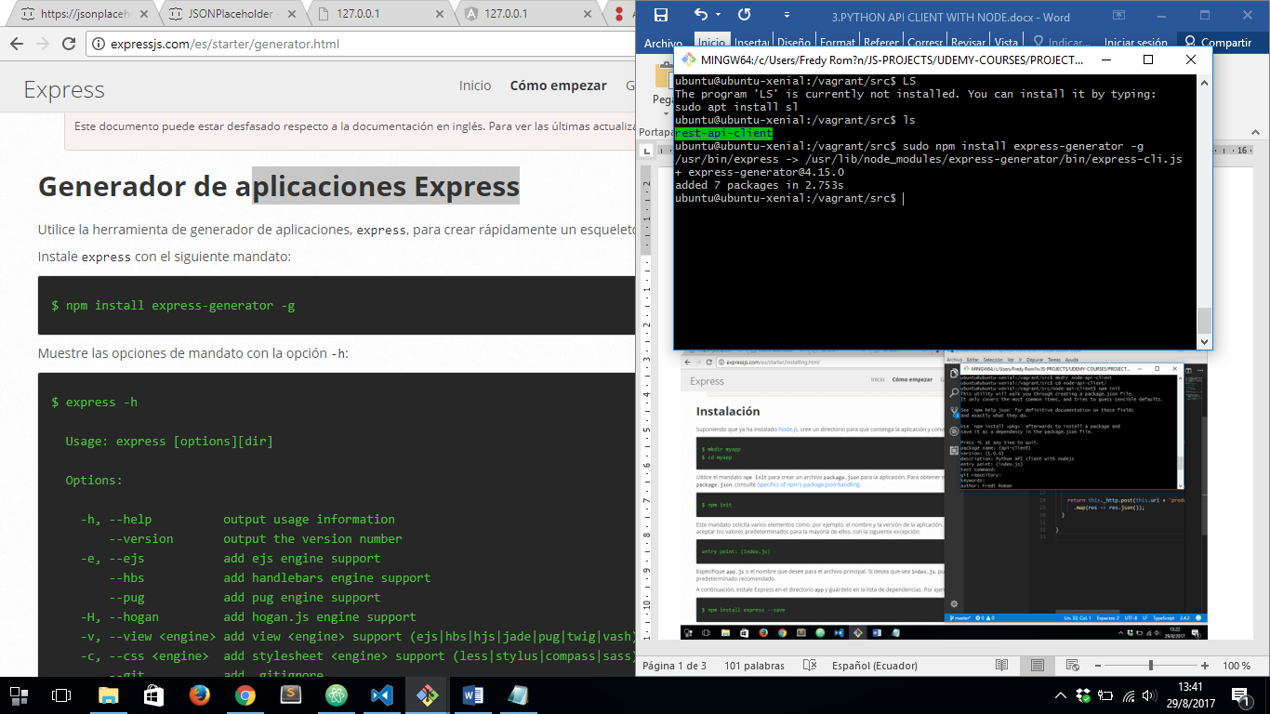

AFTER THAT WE HAVE TO CREATE AN SKELETON PROJECT USING EXPRESS GENERATOR BUT IF VIEW ENGINE IS REQUIRED TO BE ***HBS*** INSTEAD OF ***PUG***, WE NEED TO PUT ***–view=hbs*** ON NEXT COMMAND:

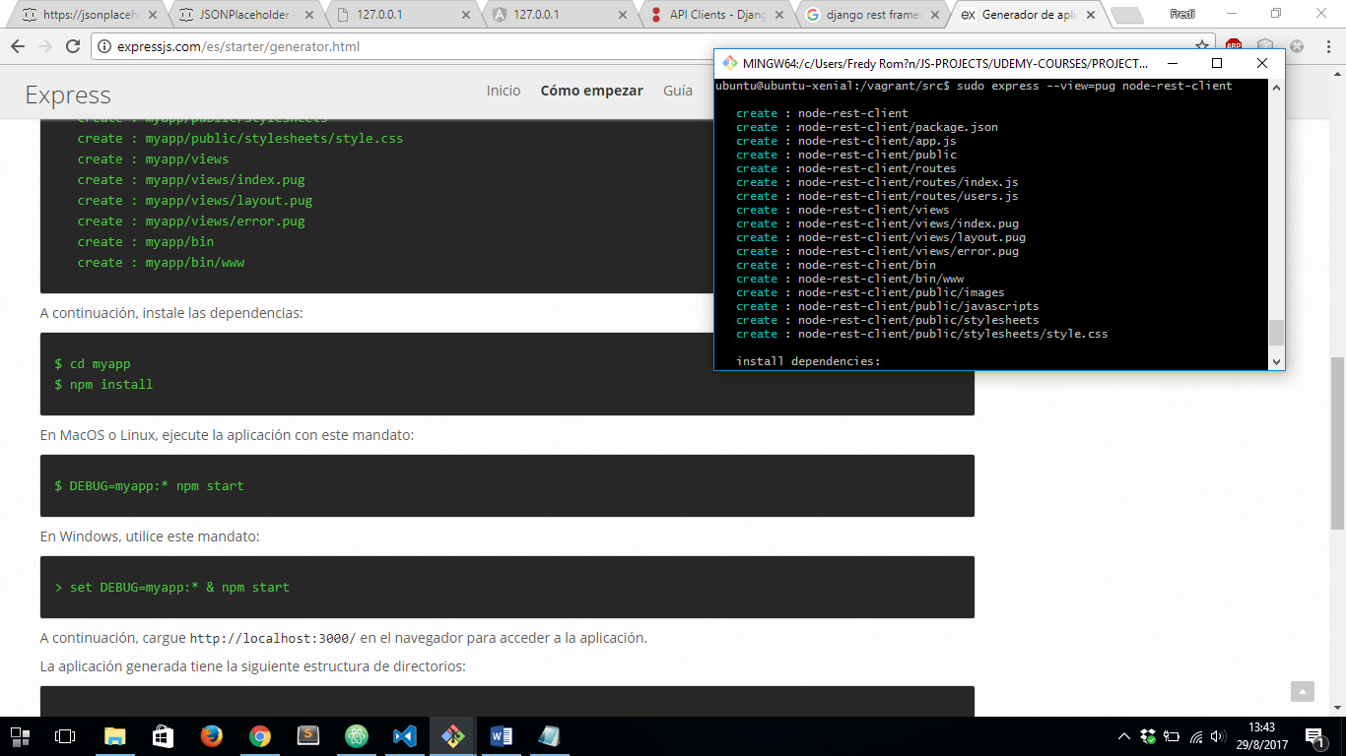

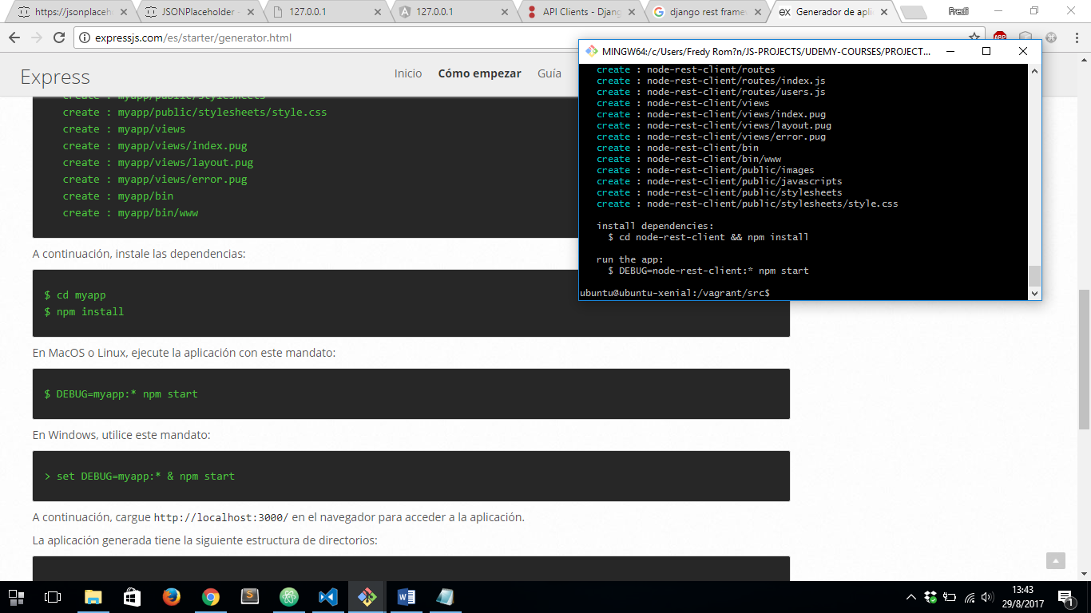

SO NOW, WE HAVE TO ACCES TO OUR PROJECT FOLDER AND RUN ***npm install*** TO INSTALL AL DEPENDECIES GENERATED WITH EXPRESS GENERATOR:

**NOTICE:** IF WE’RE USING VAGRANT BOX TO DEPLOY OUR SERVER WE NEED TO IGNORE SYMLINKS ALWAYS WE NEED TO INSTALL SOMETHING WITH NPM, REF:

<https://github.com/npm/npm/issues/9901>

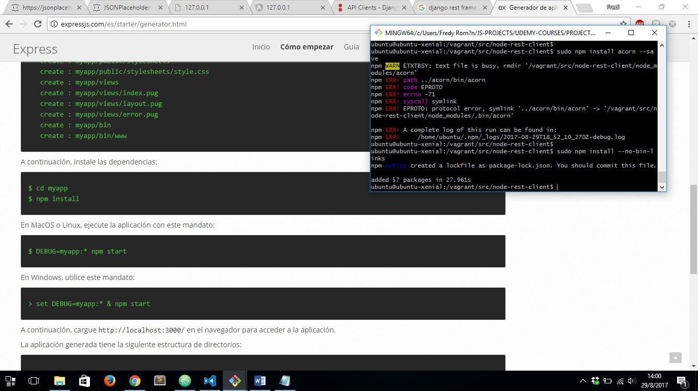

SO NOW, WE HAVE OUR SKELETON NODEJS PROJECT CREATED WITH EXPRESS GENERATOR:

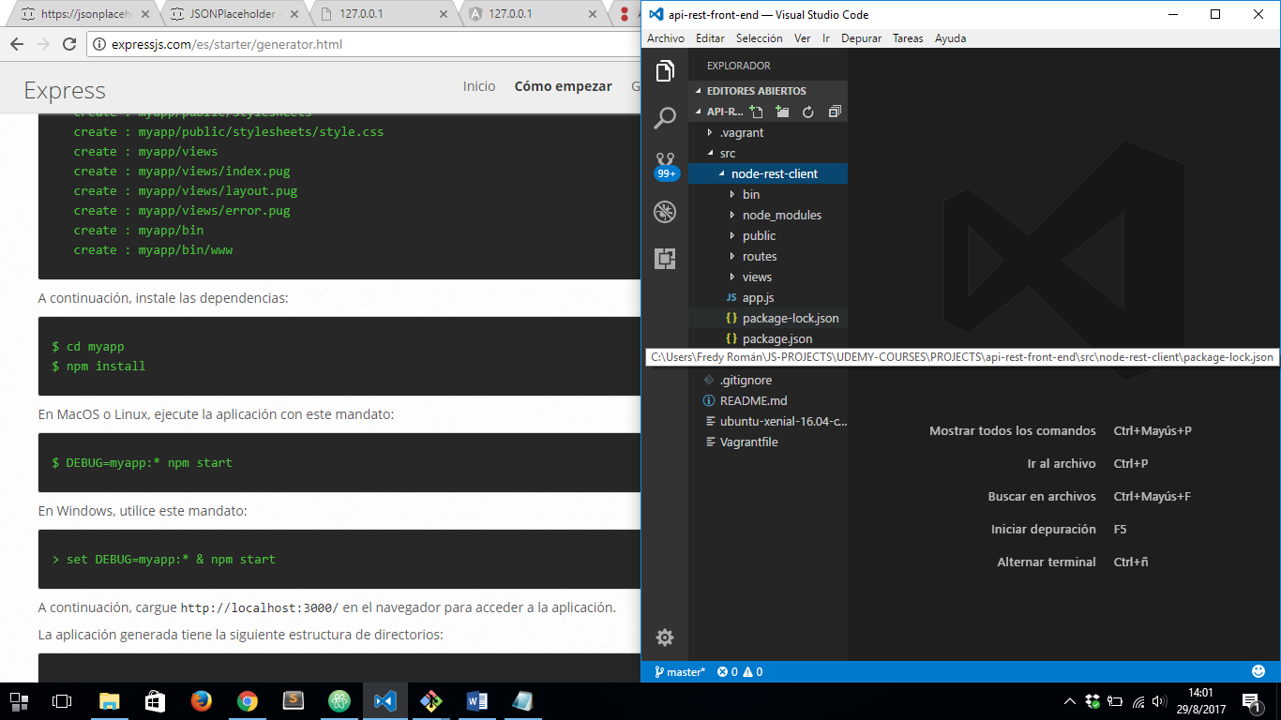

THEN WE HAVE TO RUN NEXT COMMAND TO START OUR NODE SERVER CREATED WITH EXPRESS GENERATOR:

1. FOR DEBUG MODE IN LINUX OR UNIX: ***DEBUG=node-rest-client:* npm start***
2. FOR NORMAL MODE RUN: ***npm start***

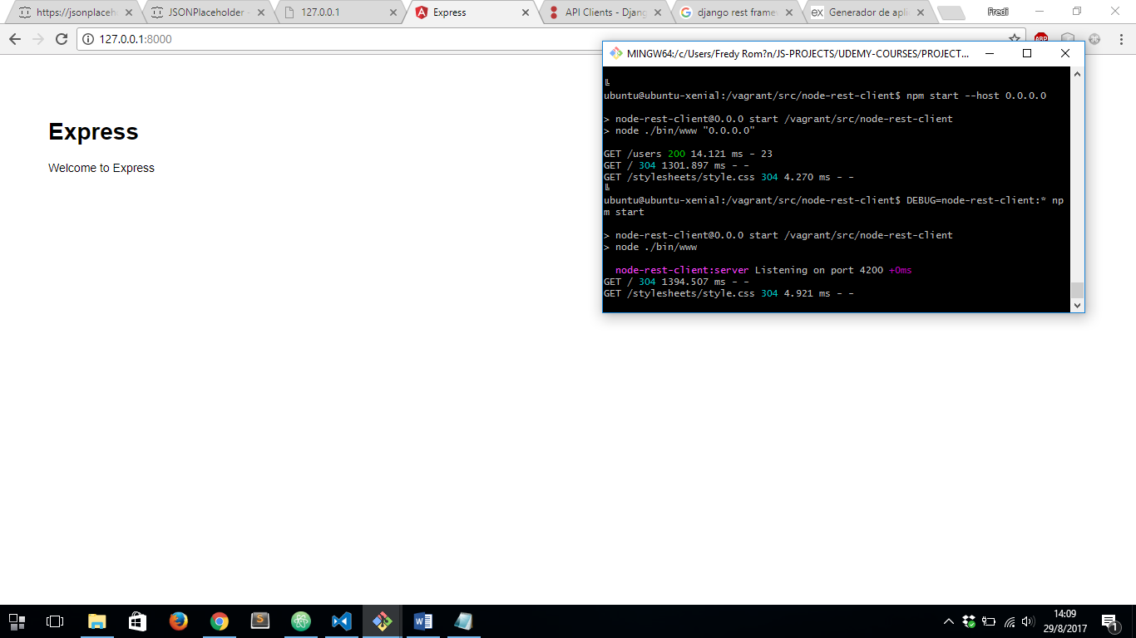

FINALLY WE HAVE OUR APP DEPLOYED:

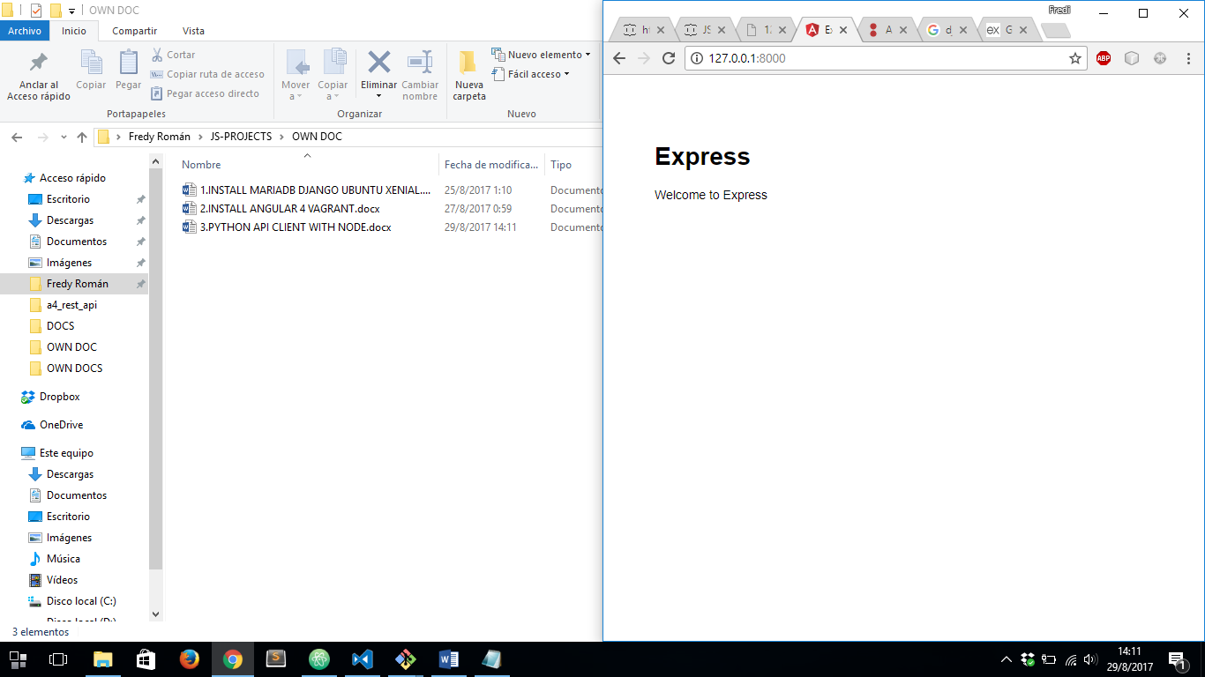

**PYTHON REST API CLIENT FOR NODE:**

REF: <https://www.npmjs.com/package/node-rest-client>

FIRST, WE HAVE TO INSTALL ***node-rest-client*** LIBRARY USING NODE NPM INSTALLATION:

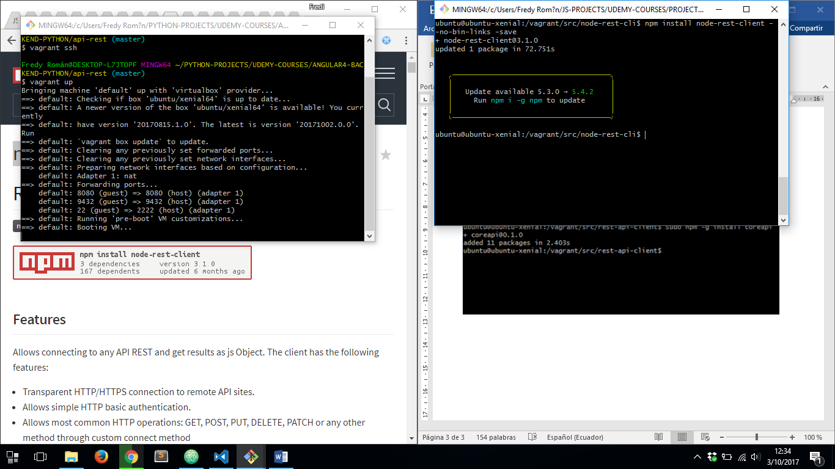

WE HAVE TO BE SURE OUR PACKAGE HAS BEEN INSTALLED SUCCESSFULY

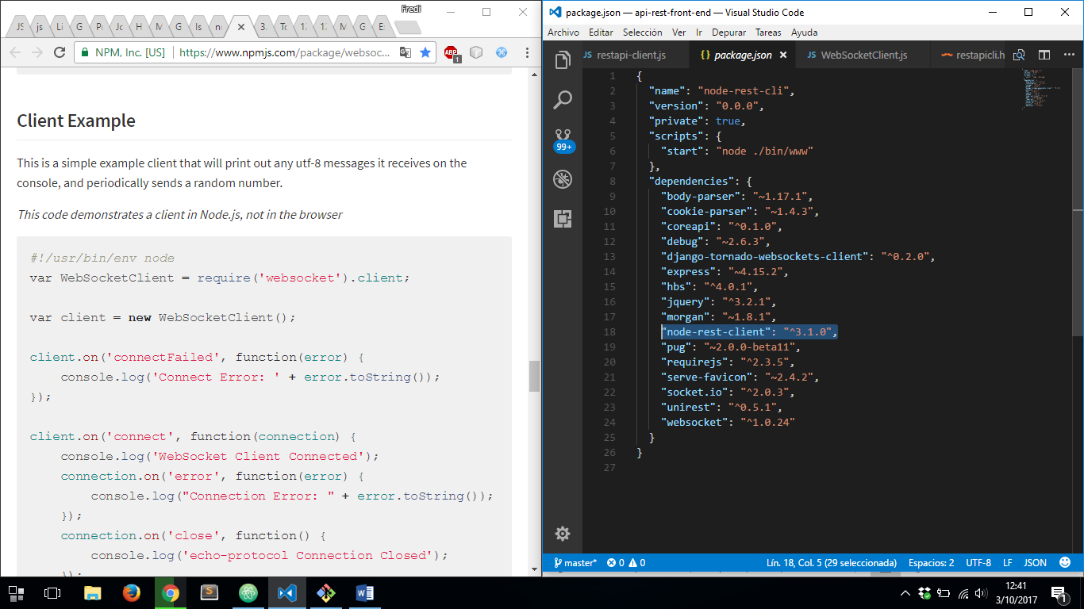

THEN WE JUST NEED TO USE OUR NODE-REST-CLIENT TO CONSUME OUR REST API FROM PYTHON, WE HAVE TO VERIFY OUR REST API IS RUNNING:

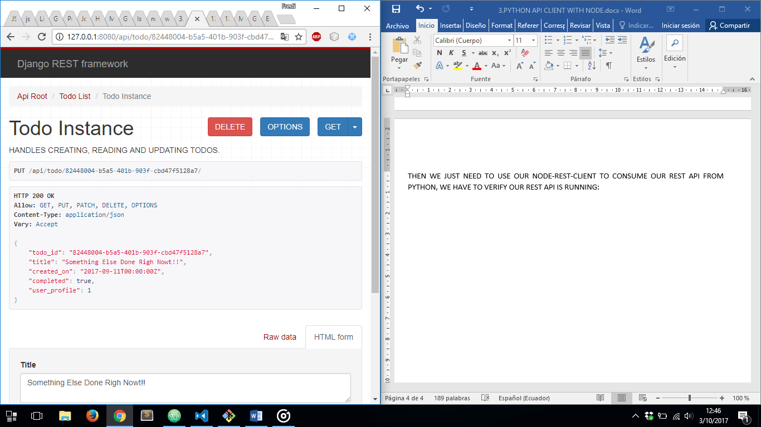

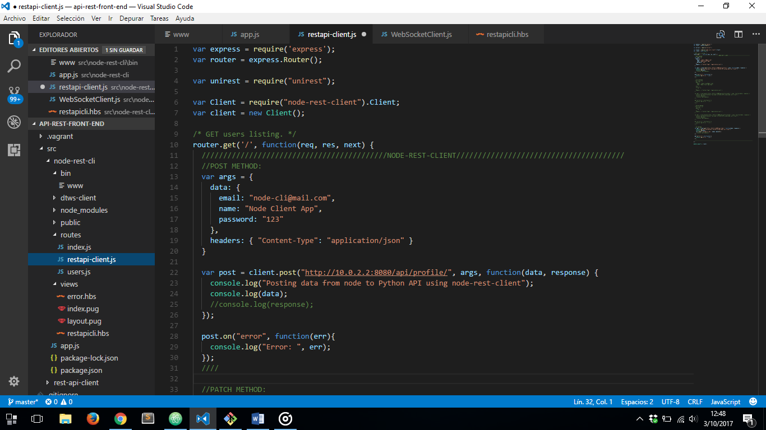WE HAVE TO CREATE A NEW ROUTE TO POST DATA TO REST API AND RETRIEVE DATA FROM IT TOO USING ***node-rest-client***:

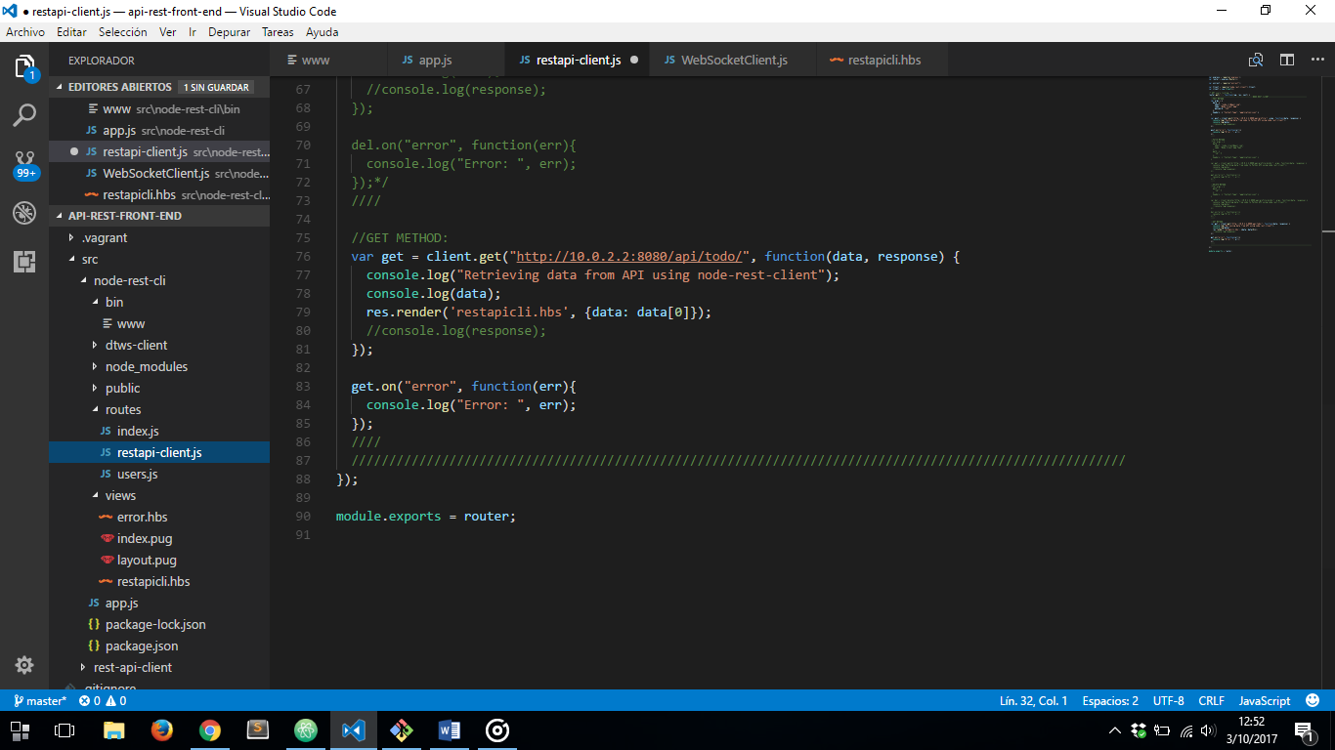

AND THEN TO TEST OUR REST CLIENT WE HAVE TO CREATE OUR VIEW:

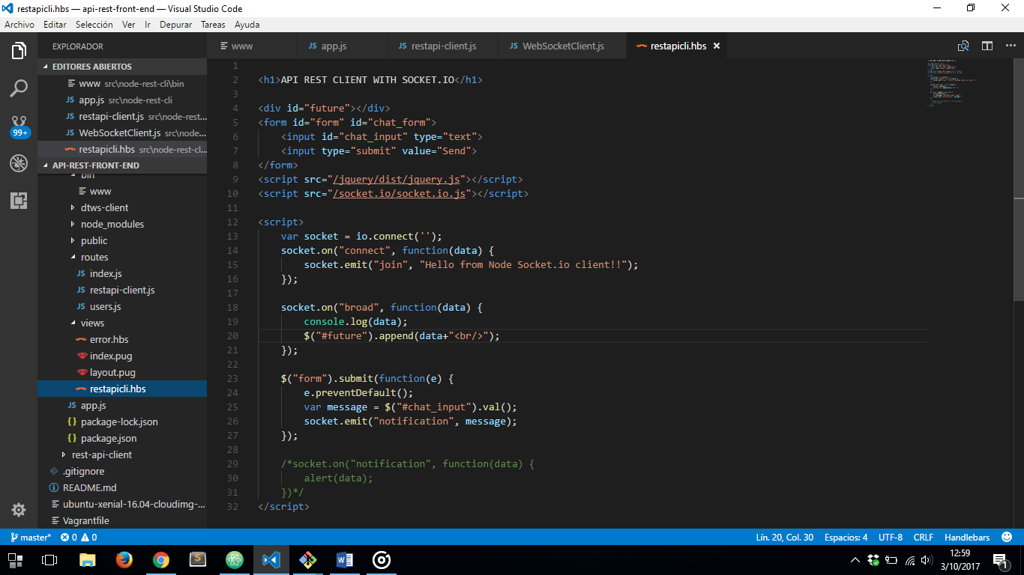

NOW IN OUR ***app.js*** FILE WE MUST DO NEXT:

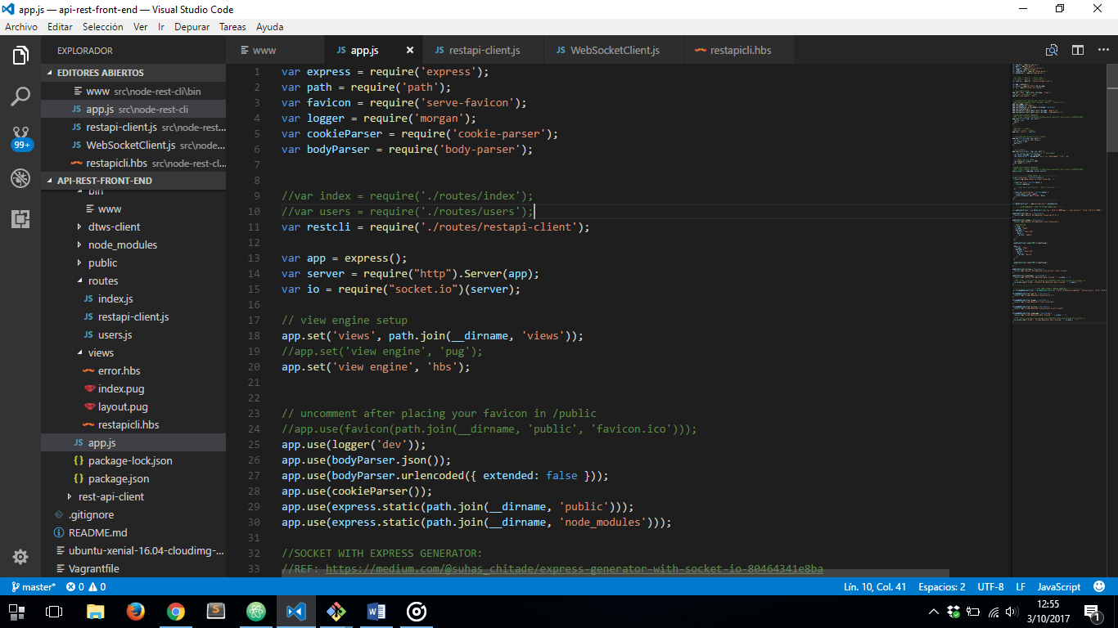

THEN WE HAVE TO ADD THE PATH TO OUR NODE_MODULES FOLDER TO BE ABLE TO USE ***node-rest-client*** MODULE:

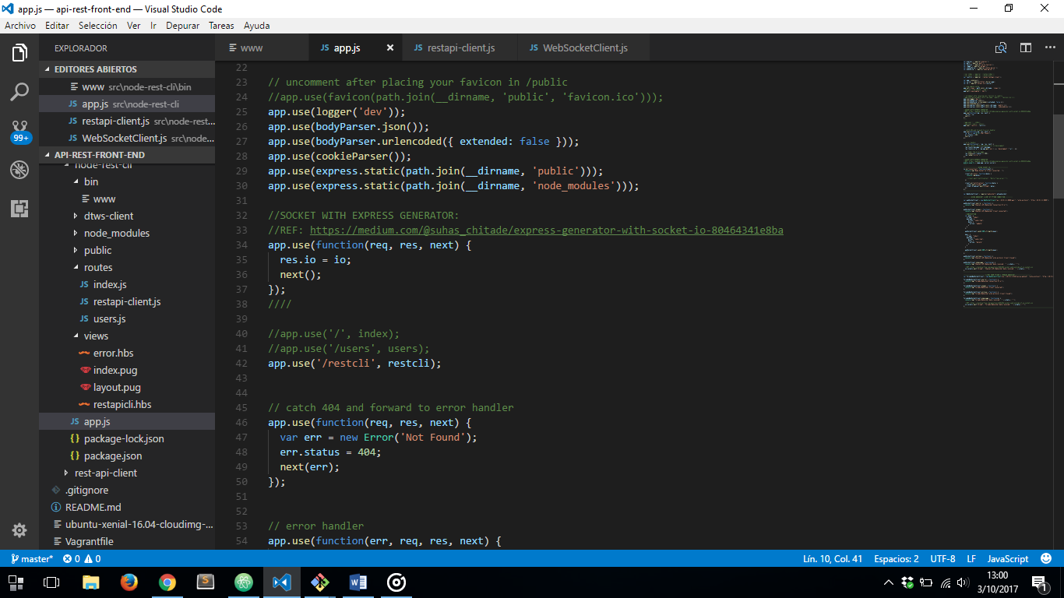

AFTER THAT WE HAVE TO DECLARE WE USE OUR NEW ROUTE:

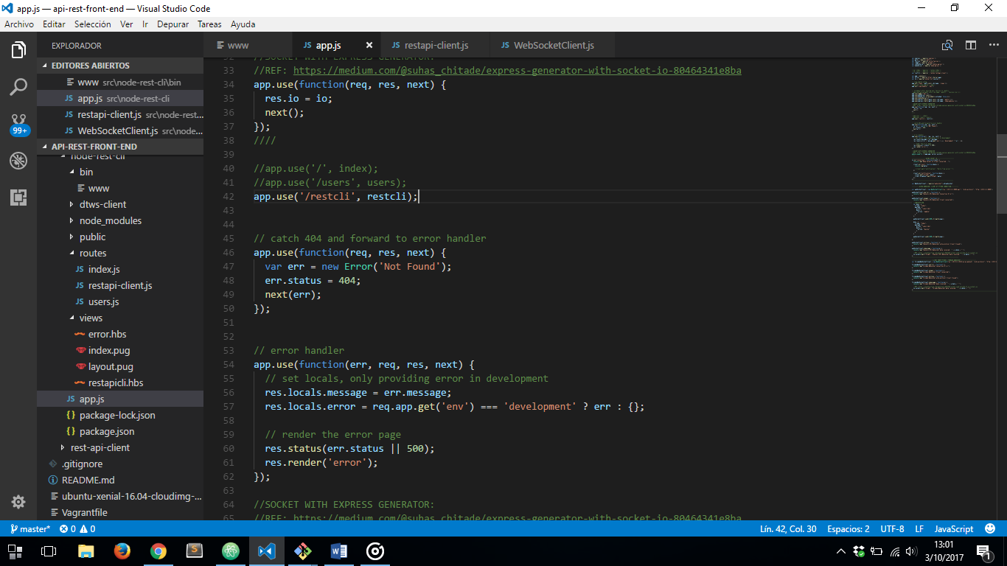

NOW WE CAN SEE OUR REST CLIENT IS RETRIEVING DATA FROM PYTHON API

